**SECOND MENTOR EVALUATION**

Capstone Project:

**F-Unlock**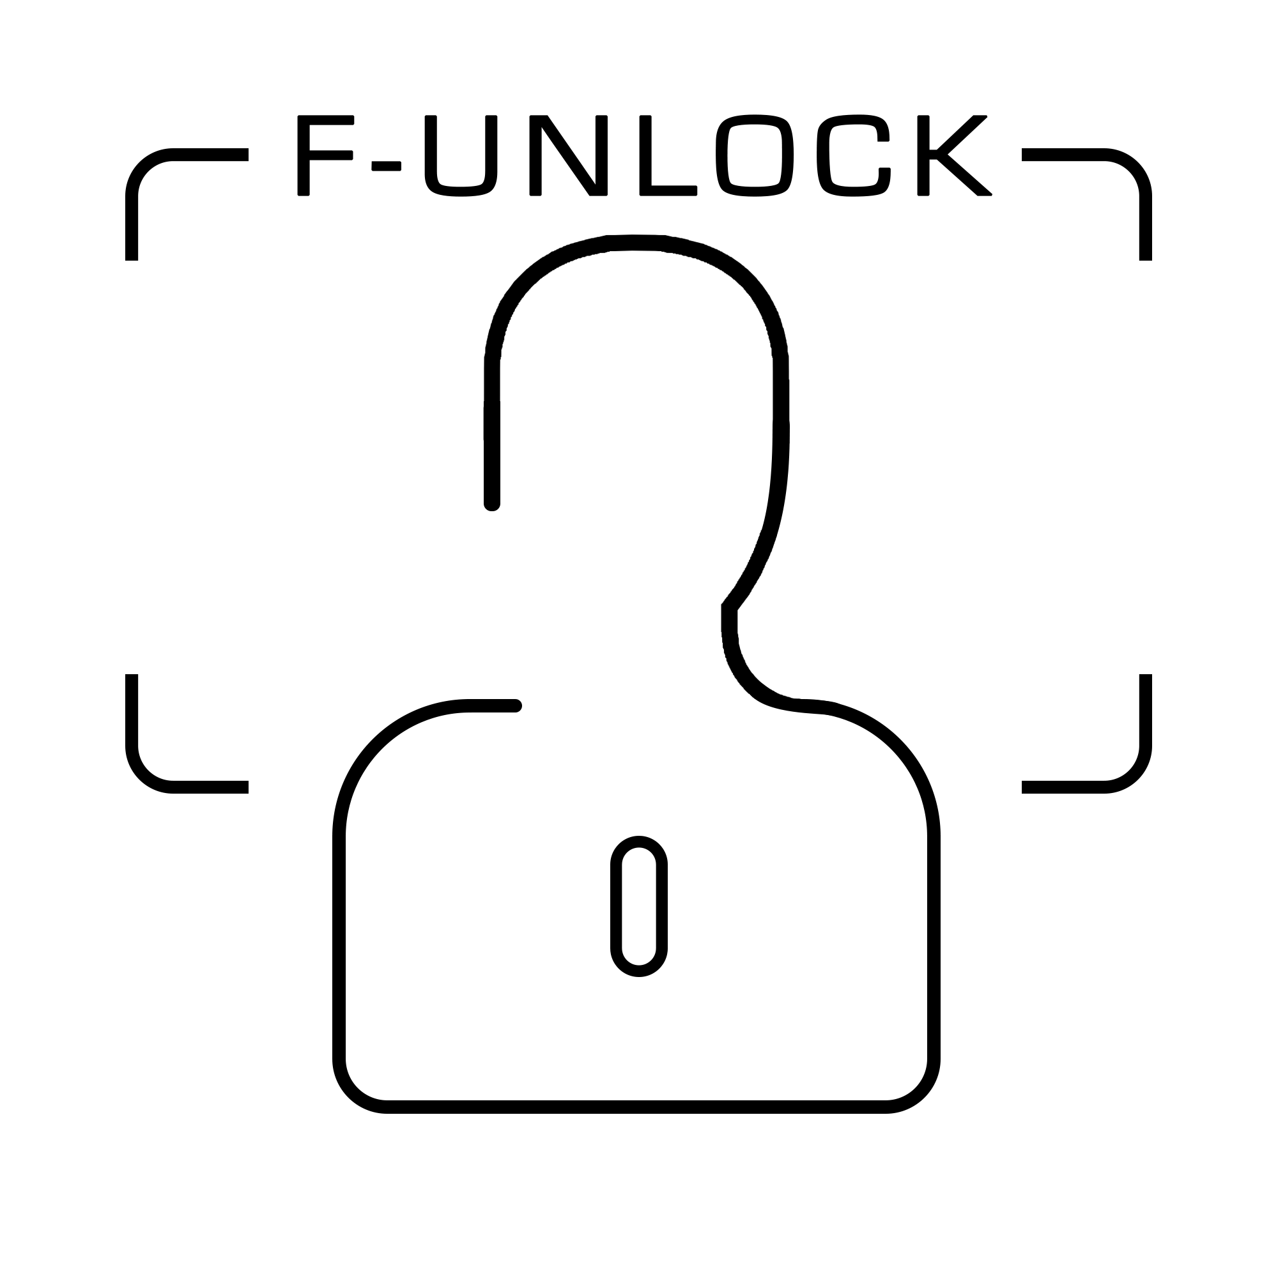

Submitted to:

*Dr. Sanmeet Kaur*

Submitted by:

|  |  |
| --- | --- |
| Abhishek Handa | 101503006 |
| Abhishek Salwan | 101503007 |
| Ajay Jindal | 101503016 |

**Table of Contents**

1. Working Principles/Analysis 2

1.1 Classification Techniques: 3

1.2 Evaluation Metrics for classification model 4

2. Cost Structure 4

3. Constraints and Assumptions 5

4. Design model 5

4.1 Architecture 5

4.2 Context Diagram 5

4.3 MVC Architecture 5

4.4 Components 6

4.5 Interface 6

4.6 Data Design 6

5. Appendix 7

A) Use Case Diagram 7

B) Class Diagram 8

C) Data Flow Diagram 9

D) Sequence Diagrams 10

# Working Principles/Analysis

There is no doubt that technology has changed the security industry. Now, one can easily find out different types of security devices equipped with innovative technology. However, there are various security solutions available to go with in terms of innovative technology, but the most effective and future-oriented one is the face recognition technology. Face recognition is considered as the future of security systems. Whether it is about installing security cameras or arranging a right biometric attendance system at a business premise, the face detecting device or software is the right option to go with because it’s fast and easy and avoids any redundant steps. This system is composed of two parts: hardware part and software part. The hardware part consists of a camera, while the software part consists of face-detection and face-recognition algorithms software. When a person enters to the zone, a series of snapshots are taken by the camera and sent to the software to be analysed and compared with an existing database of trusted people. An alarm goes off if the user is not recognized.

Phases of Face unlock software are:

1. **Face Detection**-: Human Face will be detected from an input photo taken by camera attached to hardware. The input photo is then fed to algorithm which detects the face from the photo using Histogram of Oriented Gradients algorithm. Then pre-processing is applied to the photo to proceed with further phases.
2. **Feature Extraction**-: This is to extract features from facial images. Feature extraction is done by feeding the image to CNN and the output will be 128 features. Many factors such as, facial expression, imaging conditions, occlusion of facial features and presence or absence of facial elements such as, moustaches, beards, and glasses effect the features which are extracted.
3. **Facial Classification**-: This is done using any basic machine learning classification algorithm. For accuracy purposes we will use SVM classifier which will be trained on the data and for prediction the results will show the class in which it falls.

## 1.1 Classification Techniques:

A) Pre-trained Models:

Convolutional neural networks are now capable of outperforming humans on some computer vision tasks, such as classifying images. That is, given a photograph of an object, answer the question as to which of 1,000 specific objects the photograph shows. A competition-winning model for this task is the VGG model by researchers at Oxford. What is important about this model, besides its capability of classifying objects in photographs, is that the model weights are freely available and can be loaded and used in your own models and applications.

B) SVM Classifier:

Support vector machines (SVMs) are formulated to solve multi class pattern recognition problem. We adapt SVM to face recognition by modifying the interpretation of the output of a SVM classifier and devising a representation of facial images that is concordant with multi class model. To train our SVM algorithm, we feed all the input images for a user and then perform training using SVM classifier. For prediction purposes, the SVM is then used for classifying the picture and telling whether it is recognised or not.

## 1.2 Evaluation Metrics for classification model

**Confusion Matrix**

A confusion matrix is an N X N matrix, where N is the number of classes being predicted. For the problem in hand, we have N=2, and hence we get a 2 X 2 matrix. Here are a few definitions, you need to remember for a confusion matrix:

* **Accuracy:** the proportion of the total number of predictions that were correct.
* **Positive Predictive Value or Precision:** the proportion of positive cases that were correctly identified.
* **Negative Predictive Value**: the proportion of negative cases that were correctly identified.
* **Sensitivity or Recall:** the proportion of actual positive cases which are correctly identified.
* **Specificity:** the proportion of actual negative cases which are correctly identified.

# Cost Structure

Materials Required for F-Unlock hardware

|  |  |
| --- | --- |
| 1. Raspberry PI: | ₹ 3,649.00 |
| * 1. PI Power Cable: | ₹ 235.00 |
| * 1. SD Card: | ₹ 598.00 |
| 1. 12 V Door lock: | ₹ 650.00 |
| 1. 2 Channel Relay Module: | ₹ 179.00 |
| 1. 12 V Adapter: | ₹ 164.00 |
| 1. Mini Speaker | ₹ 397.00 |
| 1. Breadboard with jumper wires: | ₹ 199.00 |
| 1. Camera: | ₹ 639.00 |
| Total | ₹ 6,710.00 |

For software the development tools used will be python, JavaScript, PHP which are open source software and won’t incur any cost.

# Constraints and Assumptions

The internet connection is a constraint for the application. Since the application fetches data from the server over the internet, it is crucial that there is an internet connection for the application to function. The face recognition algorithm should be accurate and moreover the execution of the algorithm should not take more than a second. The relay system should work properly in response to Raspberry Pi. For SOS to work the audio system must record properly and send it over the server and respond quickly to open the door. It is assumed that the system is able to provide necessary requirements for the hardware to operate along with software.

# Design model

**Table 1:Users**

|  |  |
| --- | --- |
| **Field** | **Type** |
| UserID | int(20) |
| First_name | varchar(25) |
| Last_name | varchar(25) |
| Email | varchar(25) |
| Gender | varchar(10) |

**Table 2:Admins**

|  |  |
| --- | --- |
| **Field** | **Type** |
| AdminID | int(20) |
| UserID | int(20) |

## Table 3:Face Data

|  |  |
| --- | --- |
| **Field** | **Type** |
| Face_id | int(20) |
| UserID | int(20) |
| Facial_Features | float(64) |

## Table 4: User Log

|  |  |
| --- | --- |
| **Field** | **Type** |
| Ulog_id | int(20) |
| Time | TimeStamp |
| UserID | int(20) |

**Table 5:Unknown Log**

|  |  |
| --- | --- |
| **Field** | **Type** |
| Unlog_ID | int(20) |
| Time | TimeStamp |
| Unknown_Id | int(20) |
| PhotoPath | varchar(60) |

## Table 6:SOS Log

|  |  |
| --- | --- |
| **Field** | **Type** |
| Sos_ID | int(20) |
| Audio_Path | varchar(60) |
| Time | TimeStamp |

## 

## 

## 4.1 Architecture

[Insert Text Here]

## 4.2 Context Diagram

[Insert Text Here]

## 4.3 MVC Architecture

Model View Controller or MVC as it is popularly called, is a software design pattern for developing web applications. A Model View Controller pattern is made up of the following three parts

* **Model** − The lowest level of the pattern which is responsible for maintaining data.
* **View** − This is responsible for displaying all or a portion of the data to the user.
* **Controller** − Software Code that controls the interactions between the Model and View.

|  |  |
| --- | --- |
| Model | ? |
| View | ? |
| Controller | ? |

## 4.4 Components

[Insert Text Here]

## 4.5 Interface

[Insert Here]

## 4.6 Data Design

[Insert Here]

# Appendix

## Use Case Diagram

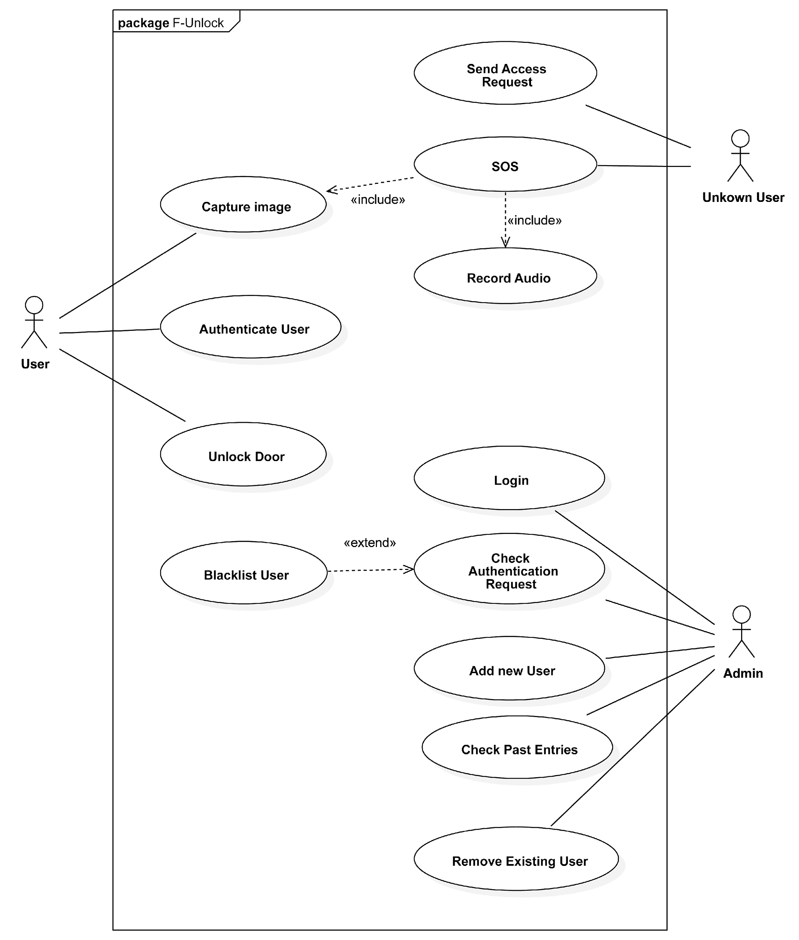

## Class Diagram

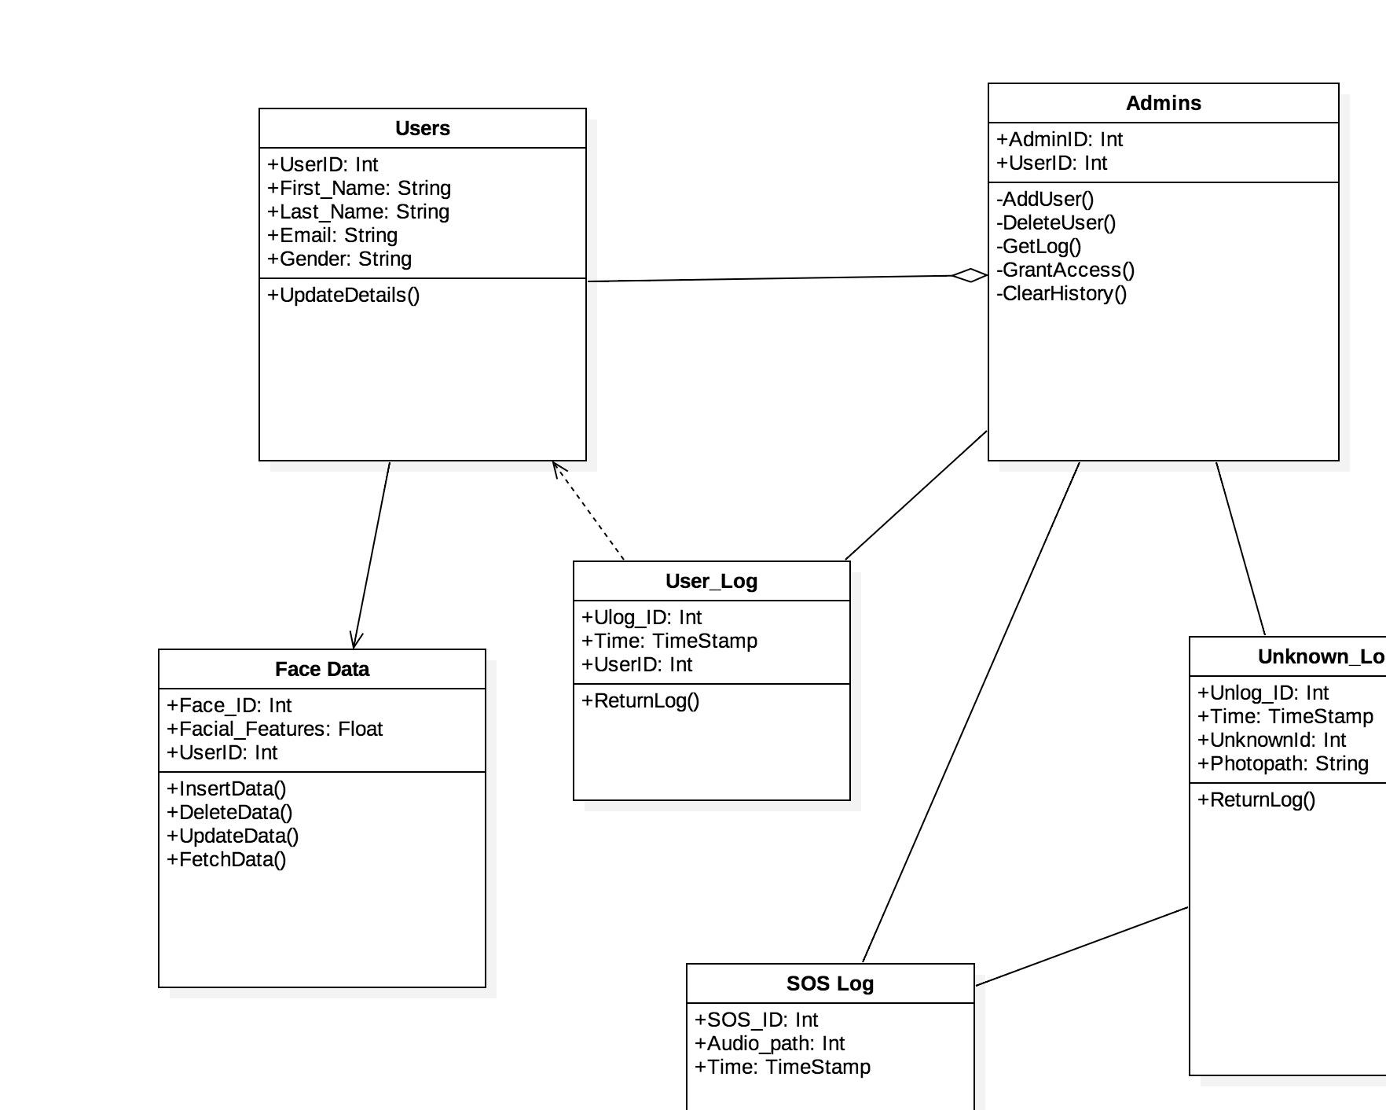

## Data Flow Diagram

Insert diagram here

## Sequence Diagrams

***Diagram 1: Login Sequence***

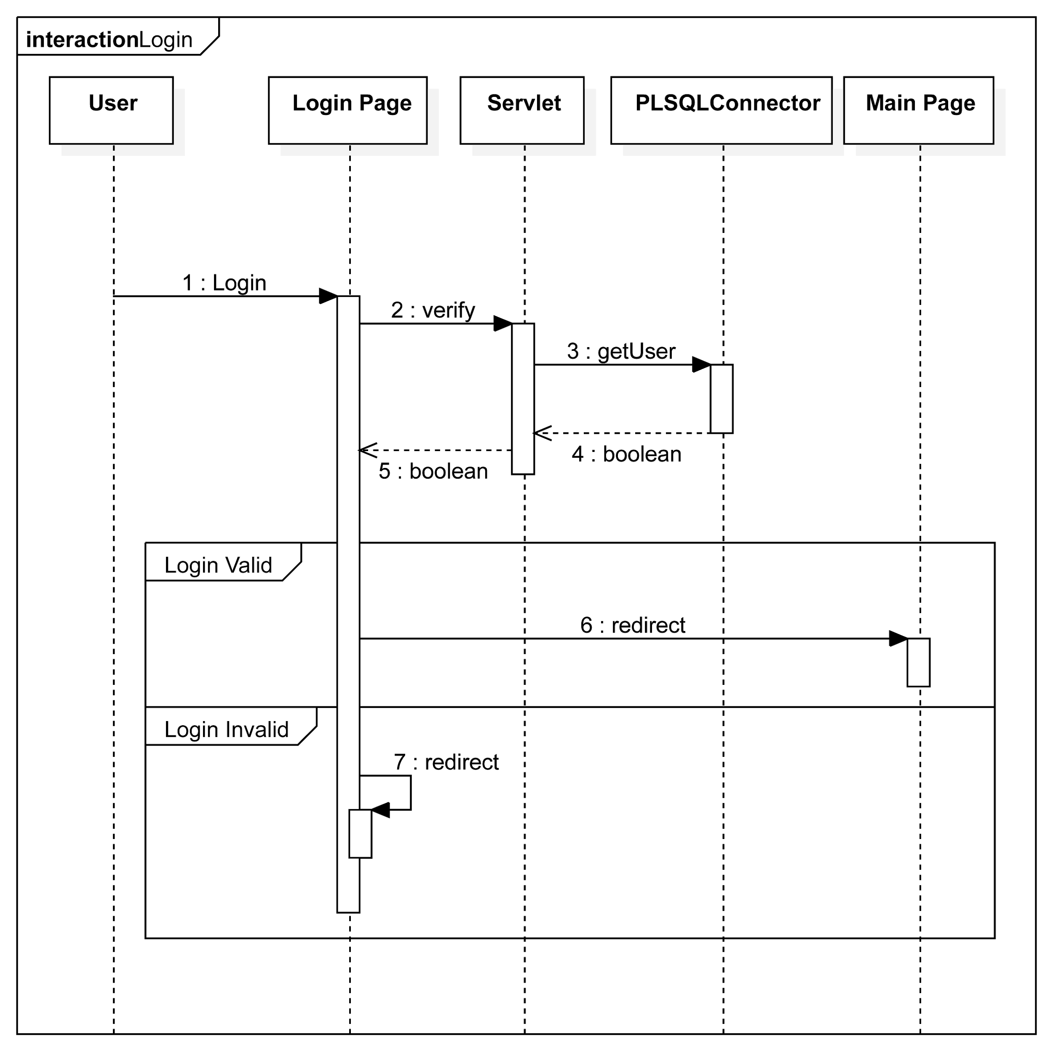

***Diagram 2: View Log***

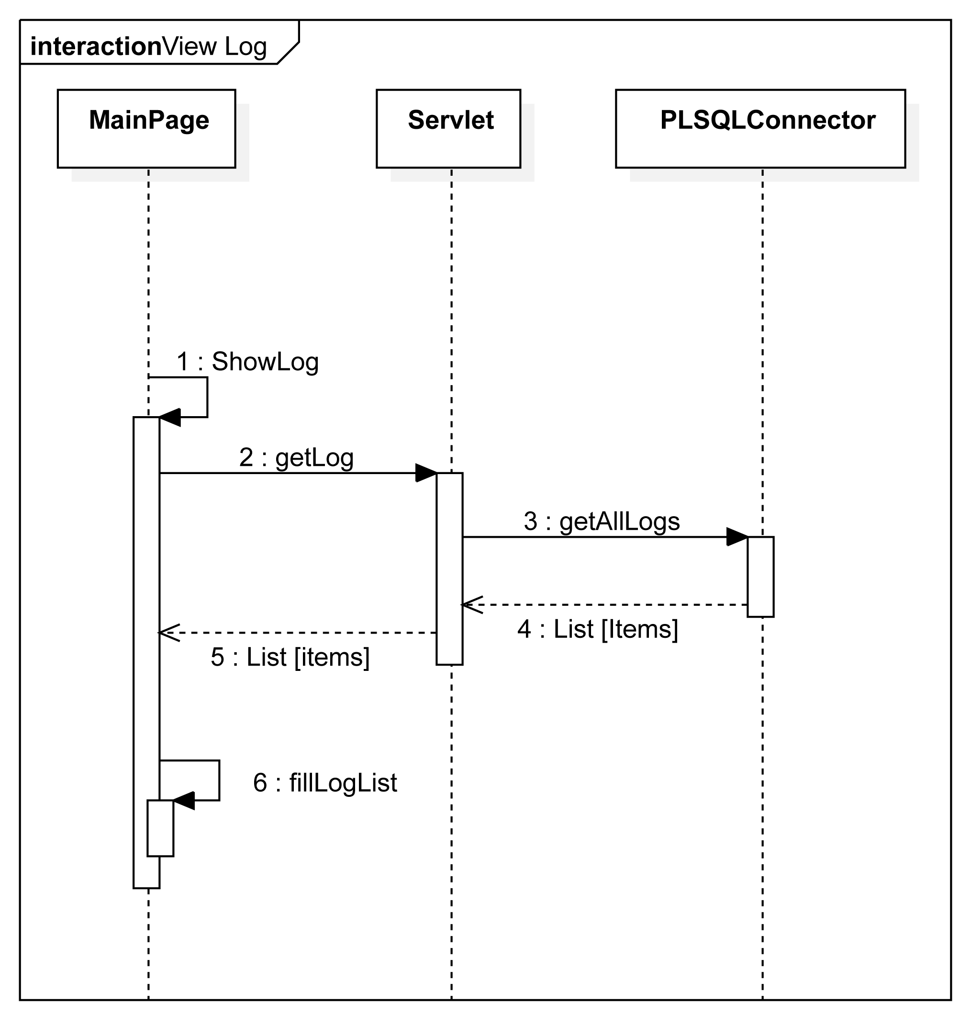

***Diagram 3: Face Recognition***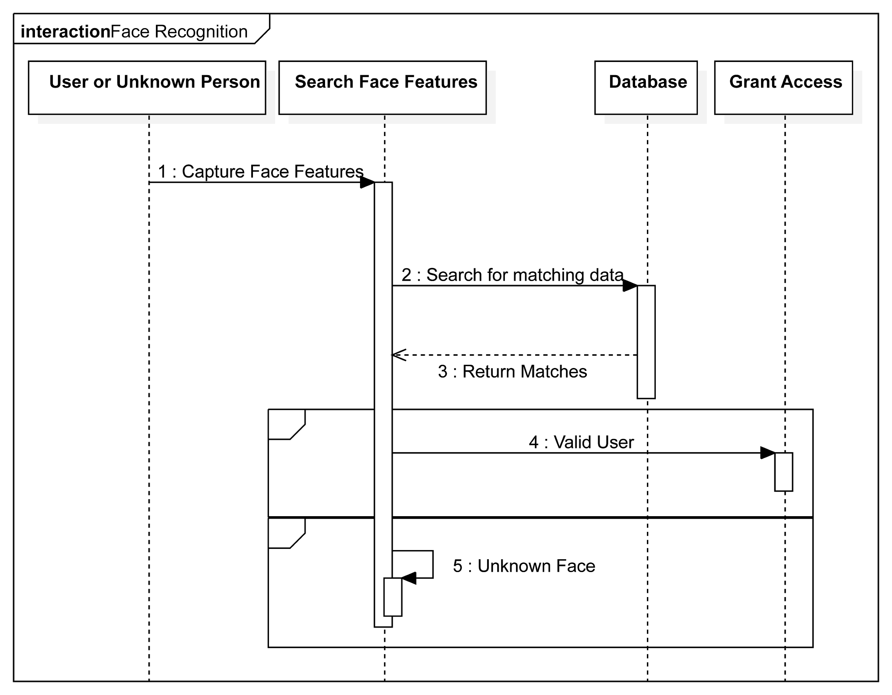

***Diagram 4: Logout***